
YOUR 15-MINUTE WORKOUT FOR LOWER BACK PAIN

STARTING POSITION #1

Lie on your back with your knees bent and feet flat on the floor. Try to feel your whole back on the floor. Breathe deeply, expand your lungs, and rest your hands on your pelvis. You should feel comfortable and relaxed.

PELVIC TILT

Tighten your abdomen and buttocks, pressing your lower back onto the floor (a small, subtle movement). Hold for a count of 5, release and repeat 10 times. Return to starting position #1.
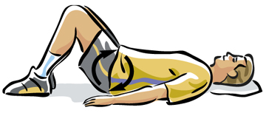

LOWER BACK ROTATION

Drop both knees to one side while rotating your head to the opposite side. Hold for a count of 5, repeat 10 times. Switch sides and repeat. Return to starting position #1.
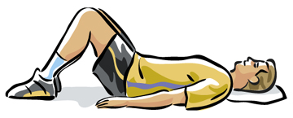
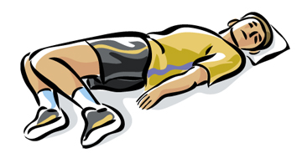

SINGLE LEG PULL

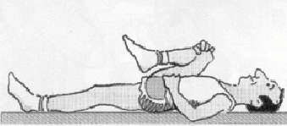
Slowly pull the bent knee to your chest while keeping your other knee and your lower back pressed against the floor. Hold for count of 5, release. Repeat 10 times, switch legs. Return to the starting position #1. Remember to breathe and relax.

DOUBLE LEG PULL

Gently pull both knees to your chest. Hold for a count of 5, repeat 5 times. Gradually work up to 20 repetitions. Return to starting position #1.
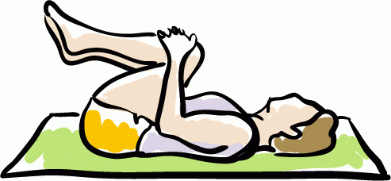

HIP LIFT

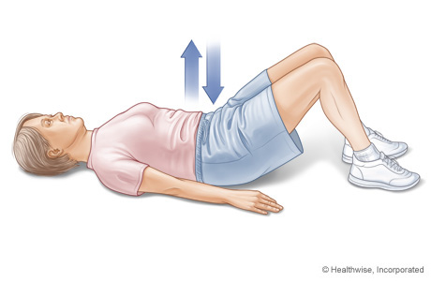
Without arching your back slowly raise your hips upwards. Keep a straight line from knees to shoulders. Hold for count of 5 and lower. Repeat 10 times. Return to starting position #1.

PARTIAL CURL-UPS

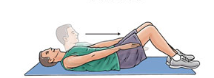
Cross your arms loosely and tuck your chin in. Tighten your abdominals and curl halfway up directly in front of you. Hold for count of 5, and then curl down. Repeat 10 times. Change to next starting position #1.

STARTING POSITION #2

Lie face down with your feet slightly apart. Relax your back and stomach muscles. Rest your forehead on the floor. For many people this position may feel awkward at first. If you have trouble relaxing your head it may help to think about looking down at your feet.

ELBOW PRESS

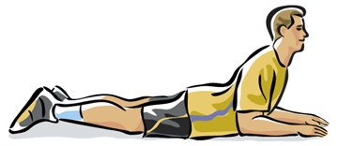
While keeping your neck in the neutral position, press yourself on your forearms. Keep your hips and abdominals against the floor. Hold for 20-30 seconds, and then lower slowly. Repeat 10 times. Change to next starting position.

STARTING POSITION #3

Switch to your hands and knees keeping your knees directly under your hips and your hands directly under your shoulders. Keep your abdomen slightly firm, so that your spine stays in neutral. Keep your neck relaxed in its natural curve so that your ears are aligned with your shoulders.

BACK PRESS

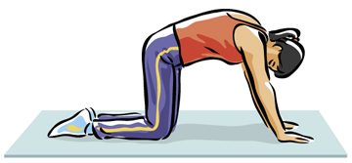
Press your back upward by tightening your abdominal and buttock muscles. Allow your head to drop slightly keeping hands and knees still. Hold for a count of 5. Return to starting position. Repeat 10 times. Return to starting position #3.

BACK RELEASE

Allow your stomach and the muscles of your buttocks to relax and let your back sag. Be sure to keep you weight evenly distributed; don’t sit back on your hips. Hold for a count of 5, and then return to starting position. Return to starting position #3.
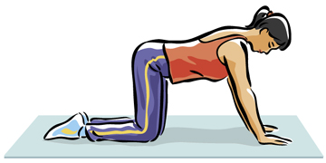

ARM REACH

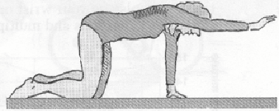
Stretch one arm straight out in front of you. Don’t raise your head, and be sure not to sink into your supporting arm. Hold for a count of 5. Return to starting position. Repeat 10 times, and then switch arms. Return to starting position #3.

LEG REACH

Extend one leg straight out behind you and hold it parallel to the floor for a count of 5. Don’t let your back, head, or stomach sag, and try not to arch your back. Return to starting position. Repeat 10 times, and then switch legs.
